Airport Data Analysis

***Wireframe Documentation***

Homepage

As per the problem statement, I designed MY first dashboard.

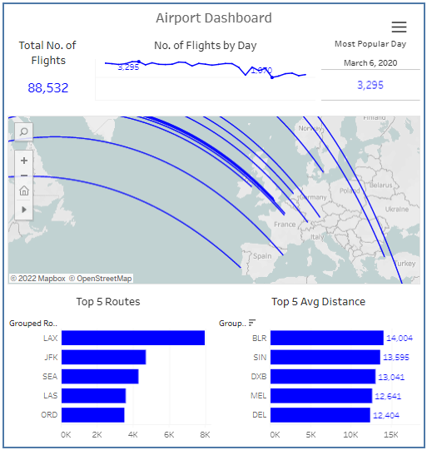

* **Total No. of Flights.**

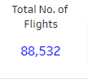

From the above visualization, we get information about the total number of flights present in our dataset.

Here, the total number of flights is equal to 88,532 .

* **No. of Flights by Day.**

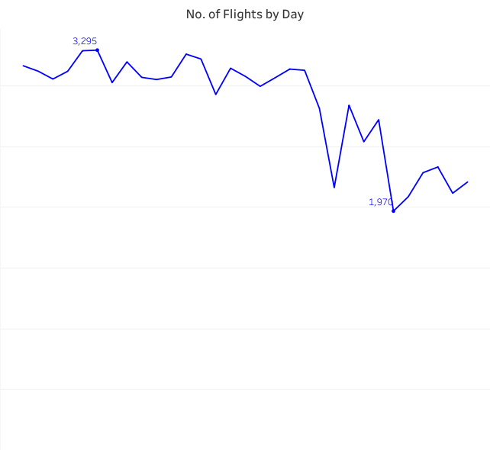

From the above visualization, we get information about the total no. of flights that operates from that day.

* **Most Popular Day.**

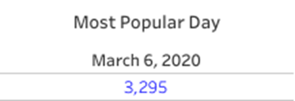

From the above visualization, we get information about the most popular day and the total no. of flights on that day.

So, the most popular day is March 6, 2020, and no. of flights on that day is 3,295.

* **Top 5 Routes.**

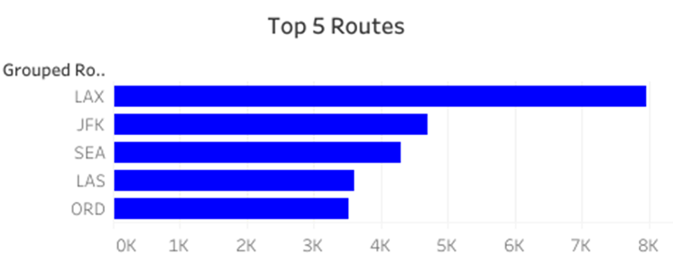

From this graph, we get information about the top 5 most popular routes.

Here, we can see that route LAX is t most popular route and JFX is the second most popular route.

* **Top 5 Average Distance.**

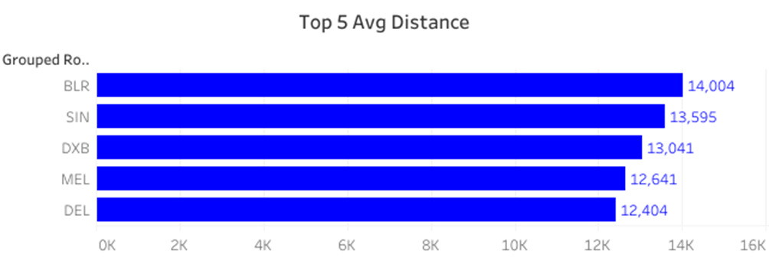

From this graph, we get information about the top 5 longest routes with respect to their average distance.

We can clearly see that route BLR is the longest route which is 14004 km long.

* **Map.**

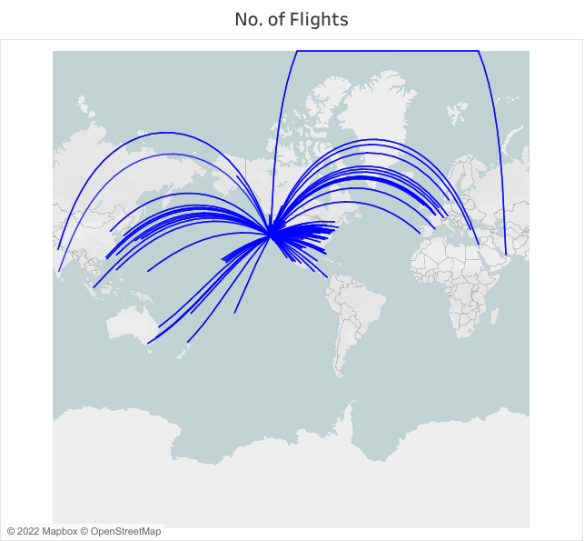

The above map gives us information about the flight path, route, and distance of that route.